
Wind Speed

The importance of studying wind velocity

Wind speed, or wind velocity, is significant to weather forecasting and affects other major functions such as the air transportation of pollen, the metabolism rate of plant species, and other anthropogenic factors. Wind speed can also be used to determine the onset of a new season or major weather occurrence. Wind velocity is typically measured with an anemometer, which is a common weather station instrument. Anemometers can be used to measure wind speed and pressure, variables that are very important to predicting weather patterns.

Wind speed is affected by various micro and macro factors, such as pressure gradient. Pressure gradient is defined as the difference in the air pressure between two atmospheric points. Essentially, the greater the difference in pressure, the faster the wind will flow from a high to low pressure atmosphere to balance out the fluctuation. Factors like hurricanes, tornadoes and monsoons can regionally and locally influence wind speed.

According to Discovering Physical Geography by Alan F. Arbogast, wind direction and velocity are influenced by following primary factors:
- Pressure gradient - the difference in barometric pressure between adjacent zones of high and low pressure.
- Frictional forces - features on the Earth's surface which oppose the wind; e.g.: mountains, trees, buildings, etc.
- Coriolis effect - the Earth's rotation causes winds to be deflected to the right in the Northern Hemisphere, and in the Southern Hemisphere to the left.
NevCAN Monitoring
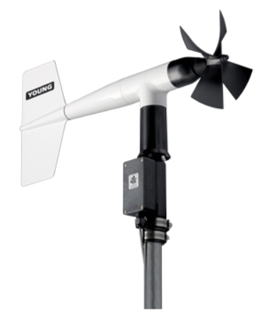
The sensor used to measure and report wind speed and direction on the NCCP website is called a propeller anemometer, specifically the RM Young Wind Vane. This model is corrosion-resistant and ideal for a wide range of wind measuring applications. The wind speed sensor is a four blade helicoid propeller. The propeller rotation produces an AC sine wave voltage signal. The wind direction sensor is a rugged yet lightweight vane. Vane angle is sensed by a precision potentiometer. Constructed of UV stabilized plastic with stainless steel and anodized aluminum fittings, the sensor mounts on standard 1 inch pipe (Young USA). This type of equipment is designed for operating temperatures -50 to 50°C, making it an ideal piece of equipment in Nevada weather.

The data collected from this sensor is made public on the NCCP website. Simply chose your desired range, time frame and measurement units.

